Problem:

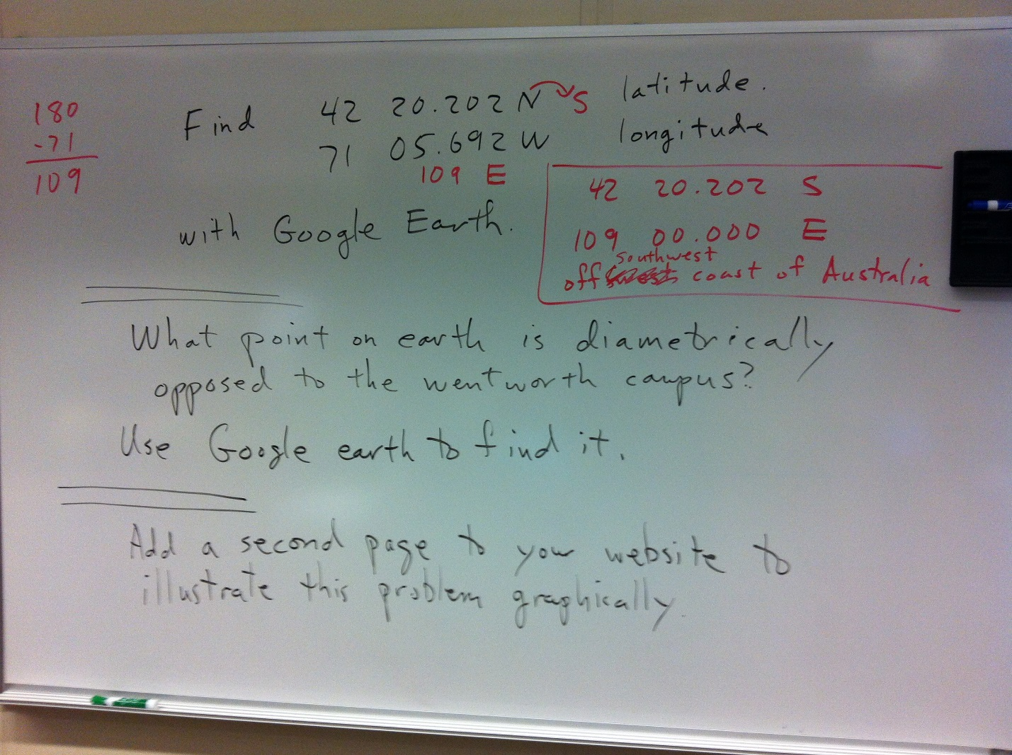

Step 1:
The point of earth that is considered Wentworth origin is given as the latitude 42 20.202 North, and longitude 71 05.692 West.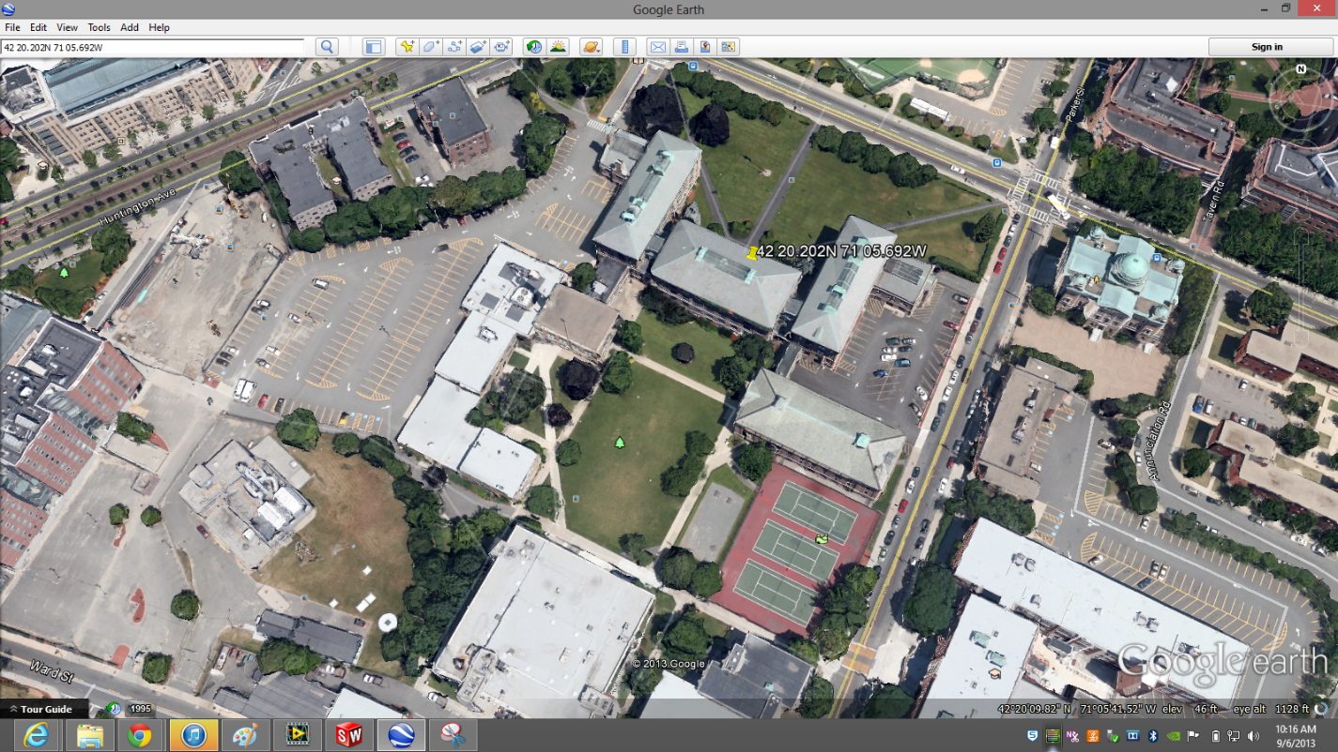

Step 2:
With the understanding of the given coordinates; what would be the diametric opposite coordinate?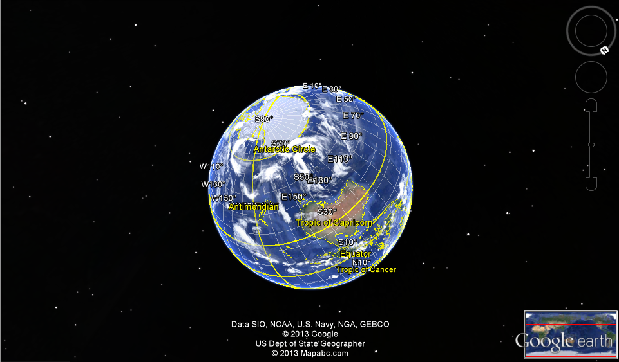
Note*
- LATITUDE RANGE FROM 0- 90 DEGREES.
- LONGATITUDE RANGE FROM 0-180 DEGREES.

Step 3:
My first ideal move would be to find the opposite coordinate by reversing the direction: North becomes 42 20.202 S, and West becomes approximately 109 east.
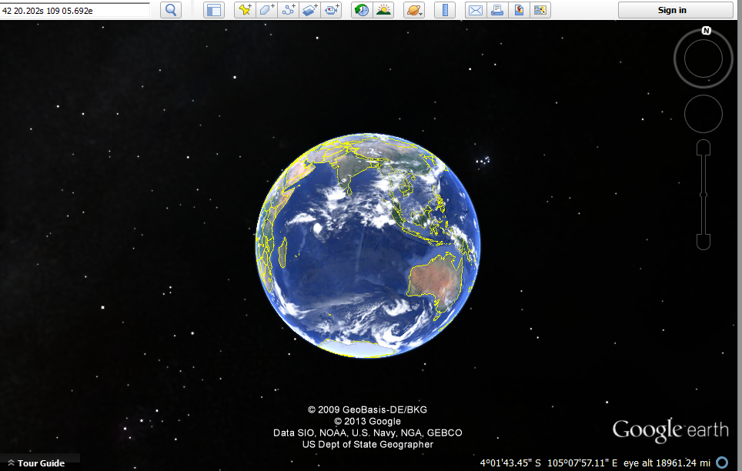

Result/Conclusion:

The Destination that is opposite to Wentworth would be just off the coast of Austria.
